Yoga Nidra
A short Training Course

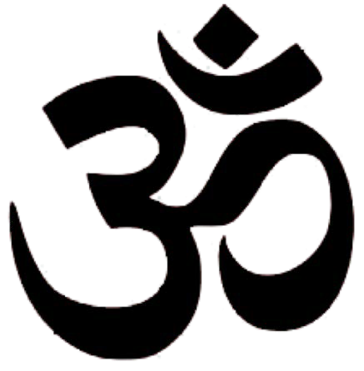
“Through the practice of Yoga Nidra, we are not only relaxing, but restructuring and reforming our whole personality from within”
Swami Satyananda Saraswati

Conducted by Swami Nirmal and Sannyasi Yagnamurti

Yoga Nidra − a Short Training Course

Aims
- To offer a systematic, well-structured course on Yoga Nidra that gives a sound basis for teachers to teach it responsibly and effectively
- To give teachers the opportunity to fully discover, explore and experience the development of the practice of Yoga Nidra for themselves.
- To enable qualified yoga teachers to deliver Yoga Nidra practice which is appropriate to their students.

Objectives
- To experience the Satyananda Yoga approach
- To understand the theory and science underlying Yoga Nidra and its eight stages.
- To explore the potential use of Yoga Nidra with a variety of student groups.
- To understand Yoga Nidra within the context of Raja Yoga.

Eligibility for the course
The course is open to those who are already a fully qualified and active yoga teacher. You would be expected to also have at least six months experience of practicing the technique yourself.

Course Requirements
- Attend all day seminars
- Do the daily practice as set
- Complete the home study assignments as required
- Students are also advised to try and attend a Satyananda Yoga class if at all possible

Duration of the Course
One day per month for 6 months totalling 39 contact hours. Each day will be from 9.00−5.00. Homework will comprise 3-5 hours study between seminars and daily practice of Yoga Nidra during the course.

Content of the Training Course

Practical
- Each session will begin with an Asana Pranayama Mudra Bandha class in the Satyananda Yoga approach
- Two Yoga Nidra Practices on each day seminar − minimum 6 hours in total − not including home practice

Theory
- The history and origins of Yoga Nidra
- The need for, and nature of relaxation
- The eight stages of Yoga Nidra
- How to teach the practice from beginners to more experienced including the use of voice and language and the development of each stage
- The place of Yoga Nidra in the wider context of yoga
- The meaning of pratyahara and its application
- The potential of Yoga Nidra − applications and responsibilities

Teaching Methods
- Lectures and discussion
- Practice and experience
- Group Discussions and group work
- Teaching practice and feedback sessions

Assessment of Studies
- Submission of six Yoga Nidra recordings with on-going assessment and feedback throughout the course
- Home study and assignments

Qualification
A certificate will be issued on successful completion of the course, qualifying the participant to teach Yoga Nidra

Dates of the Course
The course will be conducted over 6 Saturdays from January to June 2020. The dates are to be confirmed soon.

Course cost £750
A deposit of £200 will be paid on acceptance to the course, the balance may be paid in two instalments or in full by 1st January 2020 at the latest.

No. of participants 12

Course Coordinator Sn Yagnamurti

Course Venue Satyananda Yoga Centre
70 Thurleigh Road London SW12 8UD

Application
If you are interested in this course, please complete the application form (download from syclondon.com or request via e mail below) and return by post or e-mail to: Yoga Nidra Course 2020, c/o Satyananda Yoga Centre, 70 Thurleigh Road, London SW12 8UD

NB: There may also be a telephone interview with the course tutor prior to acceptance.

Contact emails: Sn Yagnamurti: yagnamurti@gmail.com
and Swami Nirmal: nirmalyoga@hotmail.com

